**ListOfPlayers.js:**

import React from "react";

export function OddPlayers({ team }){

  const odd = team.filter((_, index) => index % 2 !== 0);

  return (

    <ul>

      {odd.map((player, index) => (

        <li key={index}>{player}</li>

      ))}

    </ul>

  );

};

export function EvenPlayers({ team }){

  const even = team.filter((_, index) => index % 2 === 0);

  return (

    <ul>

      {even.map((player, index) => (

        <li key={index}>{player}</li>

      ))}

    </ul>

  );

};

**ScoreBelow70.js:**

import React from "react";

function ScoreBelow70({ players }){

  const filtered = players.filter(player => player.score < 70);

  return (

    <ul>

      {filtered.map((player, index) => (

        <li key={index}>

          {player.name} - {player.score}

        </li>

      ))}

    </ul>

  );

};

export default ScoreBelow70;

**IndianPlayers.js:**

import React from "react";

export function OddPlayers({ team }){

  const odd = team.filter((_, index) => index % 2 !== 0);

  return (

    <ul>

      {odd.map((player, index) => (

        <li key={index}>{player}</li>

      ))}

    </ul>

  );

};

export function EvenPlayers({ team }){

  const even = team.filter((_, index) => index % 2 === 0);

  return (

    <ul>

      {even.map((player, index) => (

        <li key={index}>{player}</li>

      ))}

    </ul>

  );

};

**MergedPlayers.js:**

import React from "react";

function MergedPlayers({ indianPlayers }){

  return (

    <ul>

      {indianPlayers.map((player, index) => (

        <li key={index}>{player}</li>

      ))}

    </ul>

  );

};

export default MergedPlayers;

**App.js:**

import React from "react";

import ListofPlayers from "./Components/ListOfPlayers";

import ScoreBelow70 from "./Components/ScoreBelow70";

import { OddPlayers, EvenPlayers } from "./Components/IndianPlayers";

import MergedPlayers from "./Components/MergedPlayers";

const App = () => {

    const flag = false;

    const players = [

        { name: "Kohli", score: 95 },

        { name: "Rohit", score: 88 },

        { name: "Gill", score: 67 },

        { name: "Pant", score: 55 },

        { name: "Rahul", score: 45 },

        { name: "Jadeja", score: 78 },

        { name: "Ashwin", score: 60 },

        { name: "Shami", score: 35 },

        { name: "Siraj", score: 50 },

        { name: "Kuldeep", score: 80 },

        { name: "Bumrah", score: 90 }

    ];

    const IndianTeam = ["Kohli", "Rohit", "Gill", "Pant", "Rahul", "Jadeja"];

    const T20Players = ["Rinku", "Suryakumar"];

    const RanjiTrophyPlayers = ["Pujara", "Iyer"];

    const IndianPlayers = [...T20Players, ...RanjiTrophyPlayers];

    return (

        <div style={{ padding: "20px" }}>

            {flag === true ? (

                <div>

                    <h1>List of Players</h1>

                    <ListofPlayers players={players} />

                    <hr />

                    <h1>List of Players having Scores Less than 70</h1>

                    <ScoreBelow70 players={players} />

                </div>

            ) : (

                <div>

                    <h1>Indian Team</h1>

                    <h2>Odd Players</h2>

                    <OddPlayers team={IndianTeam} />

                    <hr />

                    <h2>Even Players</h2>

                    <EvenPlayers team={IndianTeam} />

                    <hr />

                    <h2>List of Indian Players Merged:</h2>

                    <MergedPlayers indianPlayers={IndianPlayers} />

                </div>

            )}

        </div>

    );

};

export default App;

**Output:**

flag=false

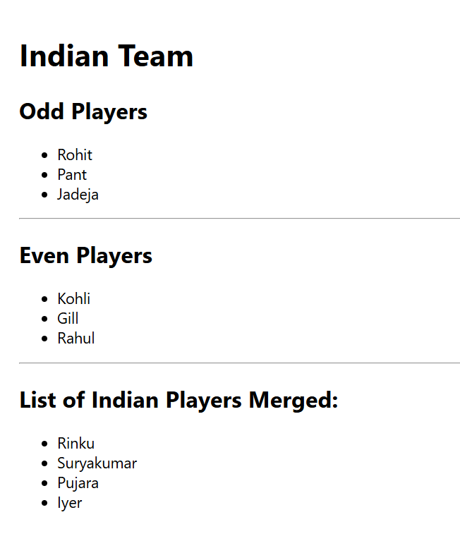

flag=true

